INS3121
SOIL MECHANICS
FINAL EXAM
January 6, 2016

S.1 | S.2 | S.3 | S.4 | S.5 | TOTAL

Name Surname:
Student No:
Group:

- a) Classify the soils below according to the “Unified Soil Classification System” (USCS).
 | Sieve No: | 4 | 10 | 20 | 40 | 100 | 200 | C_{u} | Cc | LL (%) | PL (%)
Soil A | % Passing | 100 | 79 | 72 | 63 | 60 | 55 | - | - | 54 | 19
Soil B | % Passing | 100 | 84 | 70 | 53 | 41 | 40 | 4.8 | 2.6 | 66 | 44

b) i- Draw the failure envelope for the Mohr-Coulomb theory. Write down the equation for the failure envelope and explain the terms in the equation.
ii- Briefly describe the shear box test. How can be obtain shear strength parameters from shear box test? Explain with using figures.
iii- What is the differences between the consolidation and compaction terms. Explain briefly.

Name Surname: | Student No: | Group:
2) a. Calculate the seepage loss under sheet pile per unit width.
b. Calculate the water pressure at point E.
c. Determine maximum water height for not occur a quick condition/sand boiling at the excavation bottom front of the sheet pile.
.

Name Surname: | Student No: | Group:
3) A odemeter test was conducted on soil sample taking from the normal consolidated clay layer of 9 m high (H) which located between two sand layer and compression index (Cc), initial void ratio (e₀), and consolidation coefficient (c_{v}) is found to be 0.122, 0.70, and 5.0x10⁻⁴ cm²/sec, respectively. If effective geological pressure is to be σ_{v}’=137.7 kN/m² at the center of clay and average vertical effective stress increase is to be Δσ_{v}=100 kN/m² due to constructed building;
- Calculate the total settlement of the clay soil.
- Compute the time required for 50% consolidation for this structure. (U=%50 için T=0,197)

Name Surname: | Student No: | Group:
- A series of consolidated-drained (CD) triaxial compression test was conducted on a saturated normally consolidated soil sample. Drained friction angle of soil from CD test was obtained as 31 degrees. By taking another sample from the same soil, a consolidated-undrained (CU) test was performed and when the deviatoric stress (σ₁-σ₃)_{f} and cell pressure (σ₃) reach up to 180 kPa and 200 kpa, respectively, shear failure occured.
- Determine the pore water pressure developed at failure for CU test.
- Determine the total shear strength of the clay soil when the geological pressure in filed equals to 200 kPa on the clay sample.

Name Surname: | Student No: | Group:
5) An earth fill will be constructed using sandy silt material. For the soil in borrow area, void ratio of the soil and specific gravity of soil solids were given as 0.9 and 2.65, respectively. The results of a Standart Proctor Test conducted on the soil samples are given in the table below.
γ_{n} (kN/m³) | 20,61 | 20,64 | 20,63 | 20,28 | 19,73 | 18,47 | 17,16
w (%) | 16.9 | 16 | 15.49 | 14.20 | 12.50 | 10.0 | 8.0

- Plot the compaction curve. Determine the maximum dry unit weight and optimum moisture content of the soil.
- Moist and dry mass of the soil sample taken from compacted soil are 1332 g and 1163 g respectively (V= 650 cm³). Relative compaction of 95% and optimum moisture content of ±3 were stated in specification. Determine whether the compaction meets the requirements or not.
- Calculate how much filler material is necessary for compacted fill of 45000 m³ considering the properties in part b.

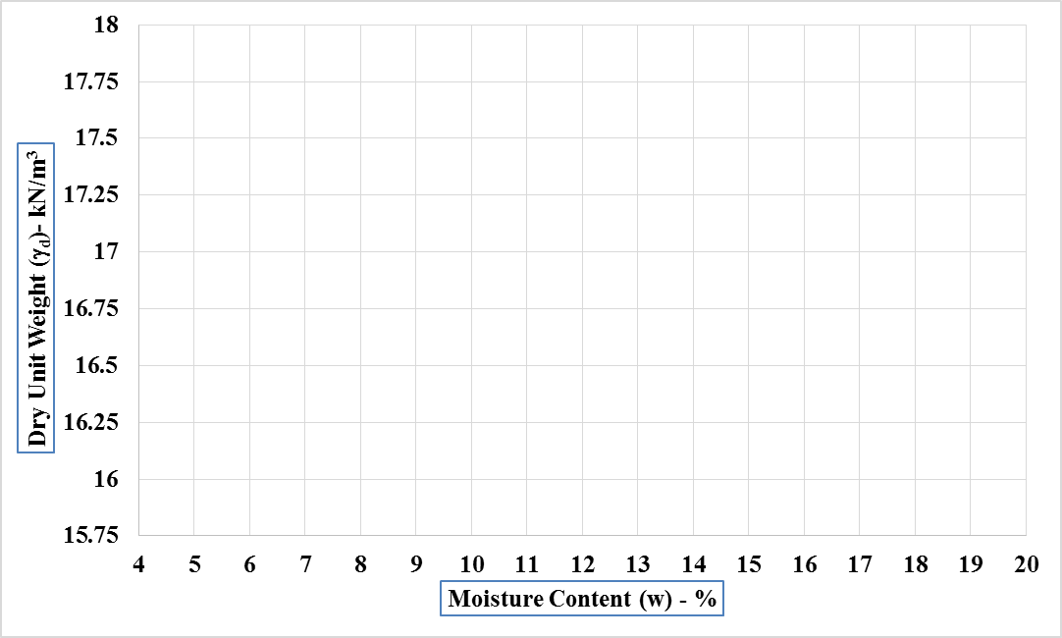

Time is 90 minutes. Good luck…

